Request New Supplier and Edit Existing Supplier New Navigation
Effective mid November 2025, a Jaggaer upgrade will change the way users navigate through the Request New Supplier and Edit Existing Supplier forms.
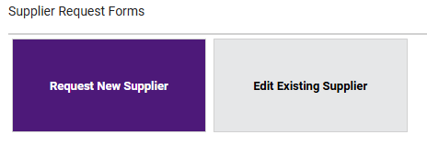
Request New Supplier
- Click on “Click Here to Start a New Supplier Request”
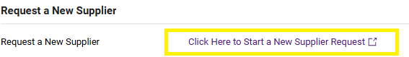
- Enter the supplier’s name and select Submit
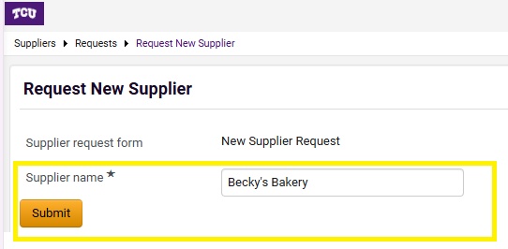
- Complete the required fields, some fields may generate additional required questions. Once all questions have been answered, select Next in the upper right-hand corner. Selecting Next saves your data and moves you along to the next “Train Stop” (i.e. page).

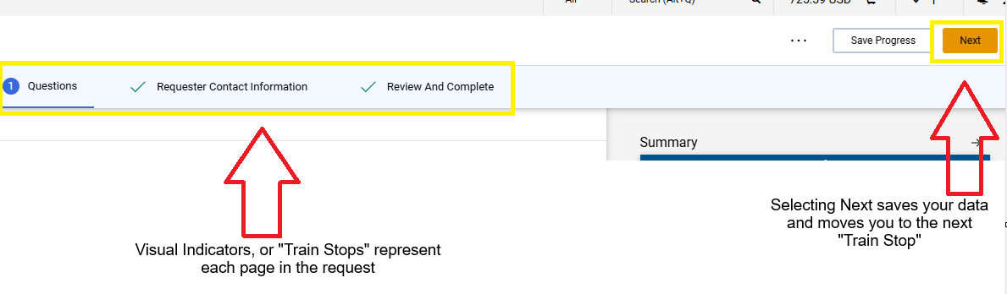

- Proceed through the required “stops”, selecting Complete Request to submit.

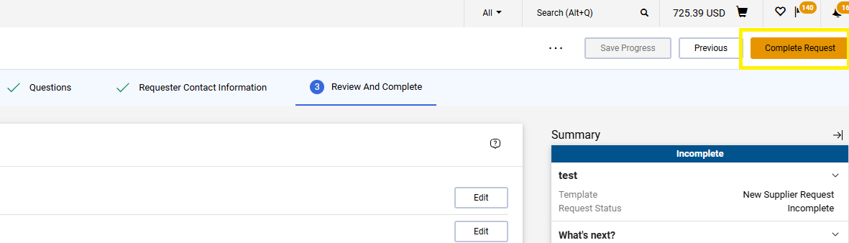
- Once you have confirmed your request to submit, the request will be listed under My Supplier Requests.

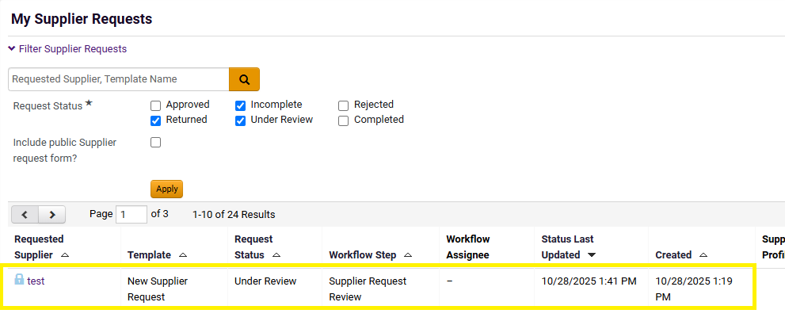

Edit Existing Supplier

- Review the Instructions, then select Next in the upper right-hand corner

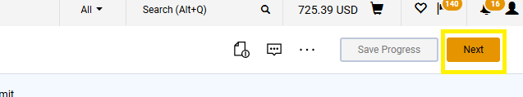

- On the Details page, enter the supplier’s name. It is important to type in the supplier’s name in the Supplier Name field, so emails to users indicating the edit has been completed, include the name of the supplier. Once entered, select Next. Selecting Next saves your data and moves you along to the next “Train Stop” (i.e. page).

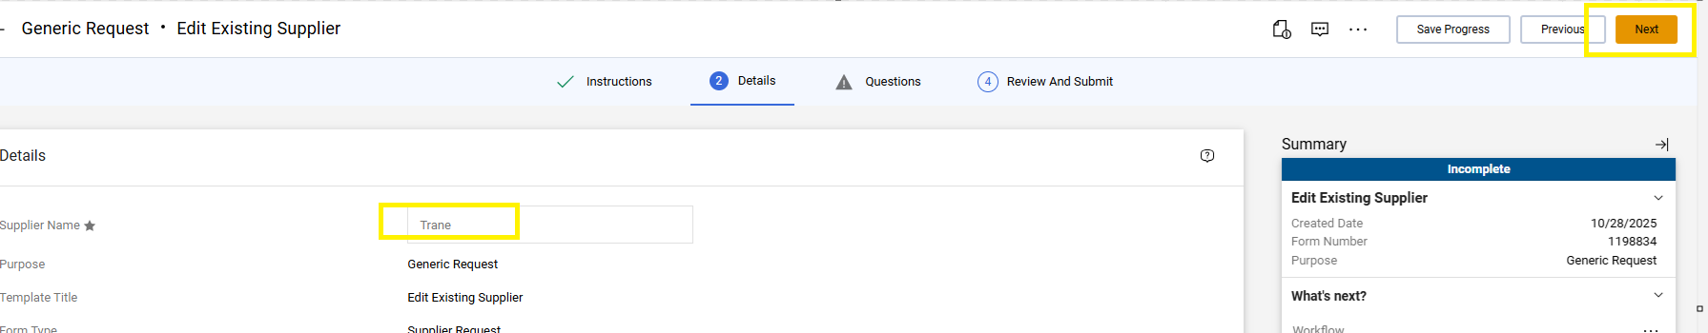

- Complete the required fields, some fields may generate additional required questions. Once all questions have been answered, select Next in the upper right-hand corner.

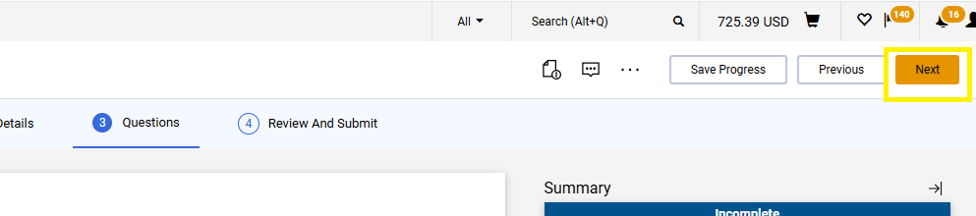

- Proceed through the required stops, selecting Submit when completed.

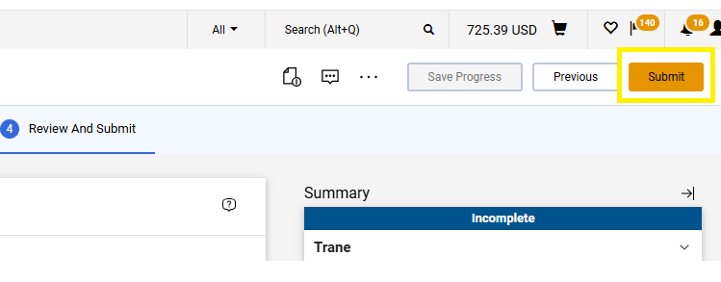
- Users will receive the Success notice once submitted.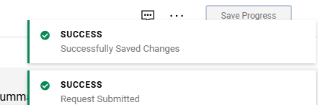

- Users can view their submitted Edit Existing Supplier requests under Orders, Requests

